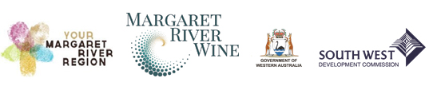

MEDIA RELEASE Embargoed until 6am, Friday 4 May 2018

Margaret River successful in competitive grant project
to boost international wine tourism

Margaret River Wine Region will receive $250,000 through the International Wine Tourism Competitive Grants Program as a component of the Australian Government’s $50 million Export and Regional Wine Support Package.

Margaret River Wine Association Chief Executive Officer Amanda Whiteland said the Margaret River application was a collaboration between the Margaret River Busselton Tourism Association, South West Development Commission, Australia’s South West, the wine industry and the Wine Association.

‘Margaret River wine exports and wine tourism are so strongly linked and it is important for the growth of our region that we work together to attract more international visitors to experience Margaret River’s diverse wine tourism offering’, she said.

Margaret River Busselton Tourism Association Chief Executive Officer Claire Savage said that this was the first time the region had seen this degree of collaboration in its marketing efforts.

‘Singapore is one of the region’s most important international markets and for the first time we have the key players coming together to target this market with an integrated program of activities – it is a huge step forward and hopefully the beginning of much greater alignment across all our marketing efforts’, she said.

Australia’s South West Chief Executive Officer Catrin Allsop said the funding was a coup for the region, and they were pleased to support the innovative application.

Building on the success of the First Class in a Glass and 50th Anniversary events held in previous years, the centrepiece of the marketing program will be a week long program of events held in Singapore. It will also include the development of content marketing assets, a famils program and digital campaign to help grow visitation from Singapore and SE Asia to the region.

Background
There were 21 successful wine tourism projects announced through the competitive grant project with a maximum of $250,000 available per project.
Grant applicants were required to provide matching funding on a dollar-for-dollar basis and projects were selected through a competitive merit-based process, based on the recommendations of an independent Expert Assessment Panel.
The successful competitive grant projects will complement broader state-based strategies that, with the support of the $50m Package, aim to attract and maximise international wine tourism in each state.
[Ends]

For further information please contact:

Amanda Whiteland
Chief Executive Officer
Margaret River Wine Association
t: +61 8 9757 9330 m: +61 417 948 736
amanda@margaretriver.wine

Sharna Kearney
Gorup Marketing Manager
Margaret River Busselton Tourism Association
m: +61 409 180 383
sharna.kearney@margaretriver.com

